**EXPERIMENT 8 : LIBRARY MANAGEMENT SYSTEM**

**AIM :**

To develop a JavaScript program that will validate the controls in the forms you have created for the application.

**ALGORITHM :**

1. User fills the form on the website with name, email, book title, and issue date.
2. Form is submitted via POST request to the servlet (BookIssueServlet).
3. Servlet receives data using request.getParameter() and processes it.
4. Servlet sends back a response displaying the submitted details in HTML.
5. Browser shows confirmation, letting the user see what they submitted.

**CODE:**

<!DOCTYPE html>

<html>

<head>

<title>Library Book Issue</title>

<link rel="stylesheet" href="style.css">

</head>

<body>

<div class="container">

<h2>Library Book Issue</h2>

<form action="BookIssueServlet" method="post">

<input type="text" name="fullname" placeholder="Full Name" required>

<input type="email" name="email" placeholder="Email" required>

<input type="text" name="book" placeholder="Book Title" required>

<input type="date" name="date" required>

<button type="submit">Submit</button>

</form>

</div>

</body>

</html>

body {

background: linear-gradient(to bottom right, #0f2027, #203a43, #2c5364);

color: white;

font-family: Arial, sans-serif;

display: flex;

justify-content: center;

align-items: center;

height: 100vh;

}

.container {

background: rgba(0,0,0,0.6);

padding: 30px;

border-radius: 15px;

box-shadow: 0 0 10px cyan;

text-align: center;

width: 350px;

}

input, button {

display: block;

width: 100%;

margin: 10px 0;

padding: 10px;

border: none;

border-radius: 8px;

}

button {

background: linear-gradient(to right, #ff416c, #ff4b2b);

color: white;

font-weight: bold;

cursor: pointer;

}

import java.io.*;

import javax.servlet.*;

import javax.servlet.http.*;

public class BookIssueServlet extends HttpServlet {

protected void doPost(HttpServletRequest request, HttpServletResponse response)

throws ServletException, IOException {

String name = request.getParameter("fullname");

String email = request.getParameter("email");

String book = request.getParameter("book");

String date = request.getParameter("date");

response.setContentType("text/html");

PrintWriter out = response.getWriter();

out.println("<html><head><title>Submission</title></head><body style='background-color:#0f2027; color:white; font-family:Arial;'>");

out.println("<div style='margin:50px auto; width:400px; background:rgba(0,0,0,0.6); padding:20px; border-radius:10px;'>");

out.println("<h2>Submitted Details:</h2>");

out.println("<p><strong>Name:</strong> " + name + "</p>");

out.println("<p><strong>Email:</strong> " + email + "</p>");

out.println("<p><strong>Book:</strong> " + book + "</p>");

out.println("<p><strong>Date:</strong> " + date + "</p>");

out.println("</div></body></html>");

}

}

<servlet>

<servlet-name>BookIssueServlet</servlet-name>

<servlet-class>BookIssueServlet</servlet-class>

</servlet>

<servlet-mapping>

<servlet-name>BookIssueServlet</servlet-name>

<url-pattern>/BookIssueServlet</url-pattern>

</servlet-mapping>

**OUTPUT:**

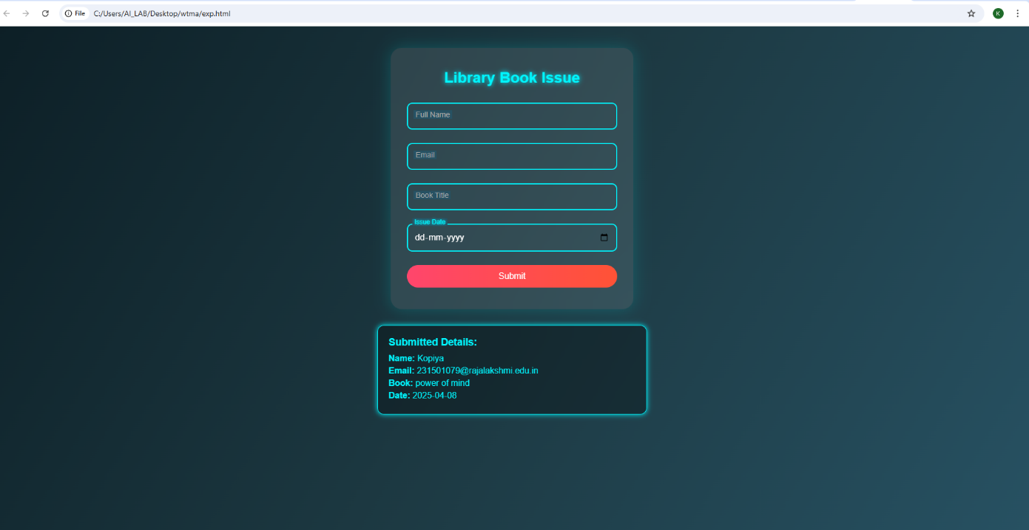

**RESULT :**

Thus developed an application for library management system.